Network Protocol Analysis:
TLS 1.3 vs QUIC Handshake Comparison
By Yogeshwaran P | ECE, SRM TRP Engineering College
1. OBJECTIVE
This mini-project analyzes how modern websites and applications establish secure, encrypted connections. Using Wireshark, live network traffic was captured while accessing GitHub (TCP + TLS 1.3), WhatsApp Web (TCP + TLS 1.3, session-resumed), and YouTube (QUIC over UDP). The goal was to understand and compare the handshake mechanics of the traditional TCP+TLS stack against the newer QUIC protocol.
2. TOOLS USED
- Wireshark — packet capture and protocol dissection
- Python + Scapy — offline .pcapng parsing and TLS layer extraction
- Capture interface: Wi-Fi (dual-stack IPv4/IPv6, NAT64 network)
3. GITHUB — TCP + TLS 1.3 HANDSHAKE
A fresh connection to github.com was captured from the very first DNS query through to encrypted application data.
Observed Sequence
- DNS Query/Answer for github.com → resolved to a NAT64 IPv6 address (64:ff9b::14cf:4952) mapping the real IPv4 20.207.73.82
- TCP 3-Way Handshake: SYN → SYN-ACK → ACK on port 443
- TLS Client Hello sent immediately after the TCP handshake completed
- TLS Server Hello + Change Cipher Spec + encrypted Certificate returned by GitHub's server
- Client Change Cipher Spec + first encrypted Application Data — page content begins loading
Key Details Extracted from the Client Hello
Field | Value
SNI (Server Name) | github.com
TLS Versions Offered | TLS 1.3, TLS 1.2
Cipher Suites Offered | TLS_AES_128_GCM_SHA256, TLS_AES_256_GCM_SHA384, TLS_CHACHA20_POLY1305_SHA256, +13 legacy suites
Key Exchange Groups | X25519MLKEM768 (post-quantum hybrid), x25519, secp256r1, secp384r1
ALPN | h2 (HTTP/2), http/1.1

Server's Response
- Cipher chosen: TLS_AES_128_GCM_SHA256
- TLS version confirmed: TLS 1.3
- Key share group chosen: x25519
Interesting finding: GitHub's Client Hello offered X25519MLKEM768 — a post-quantum hybrid key-exchange group. This shows the browser proactively offering quantum-resistant cryptography, even though the server ultimately chose the classical x25519 curve. This reflects the industry's early migration toward post-quantum-safe TLS.
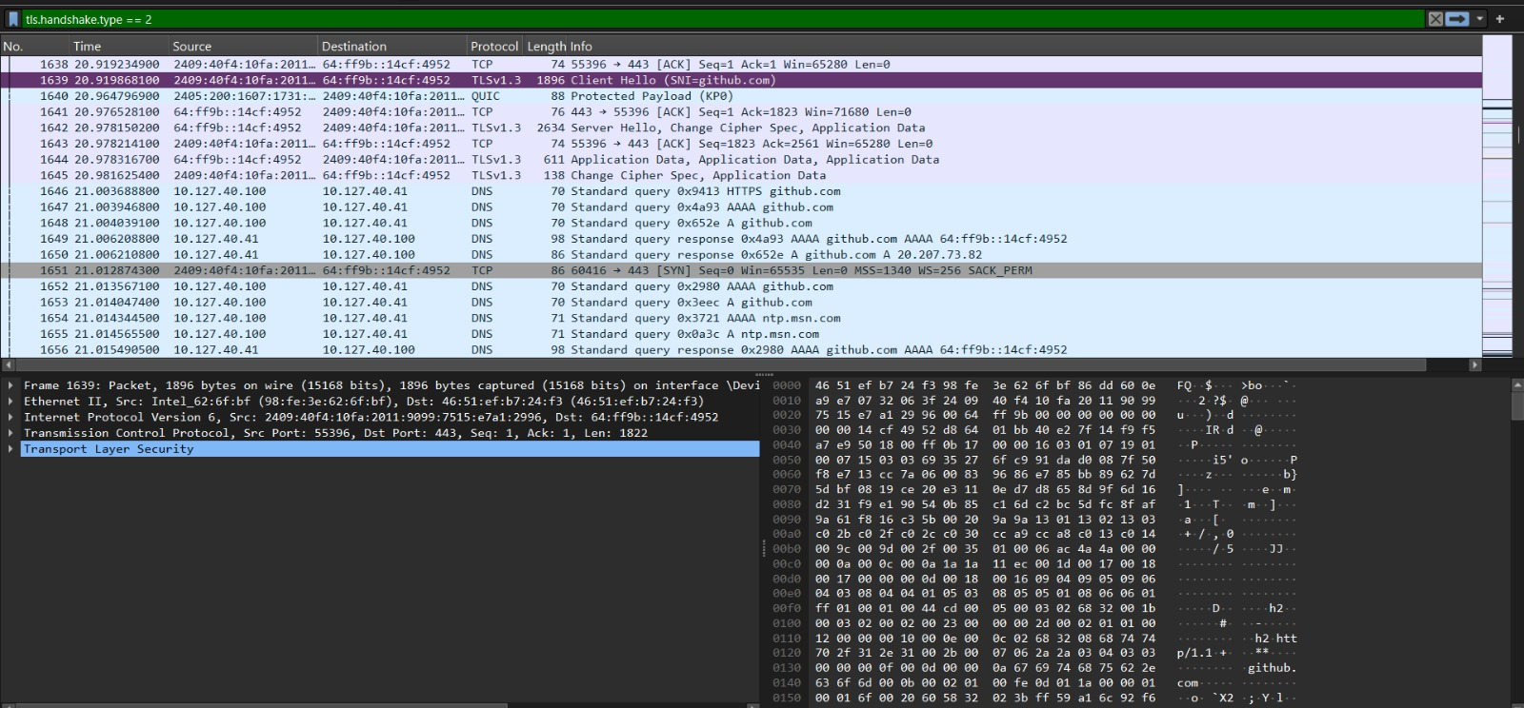
Fig 1: TCP + TLS handshake sequence captured in Wireshark (SYN, SYN-ACK, Client Hello, Server Hello, Certificate exchange).
4. WHATSAPP WEB — TLS SESSION BEHAVIOUR
The capture for web.whatsapp.com showed a slightly different pattern from GitHub.
- DNS queries for web.whatsapp.com were repeated multiple times in a short window — consistent with WhatsApp Web's frequent reconnection/keep-alive checks
- TLS Application Data packets appeared without a fresh visible Client Hello in this capture window, indicating an already-established TLS session was reused (session resumption) rather than a full handshake
- This is a good real-world example of TLS session resumption — a performance optimization that skips the full handshake for returning connections
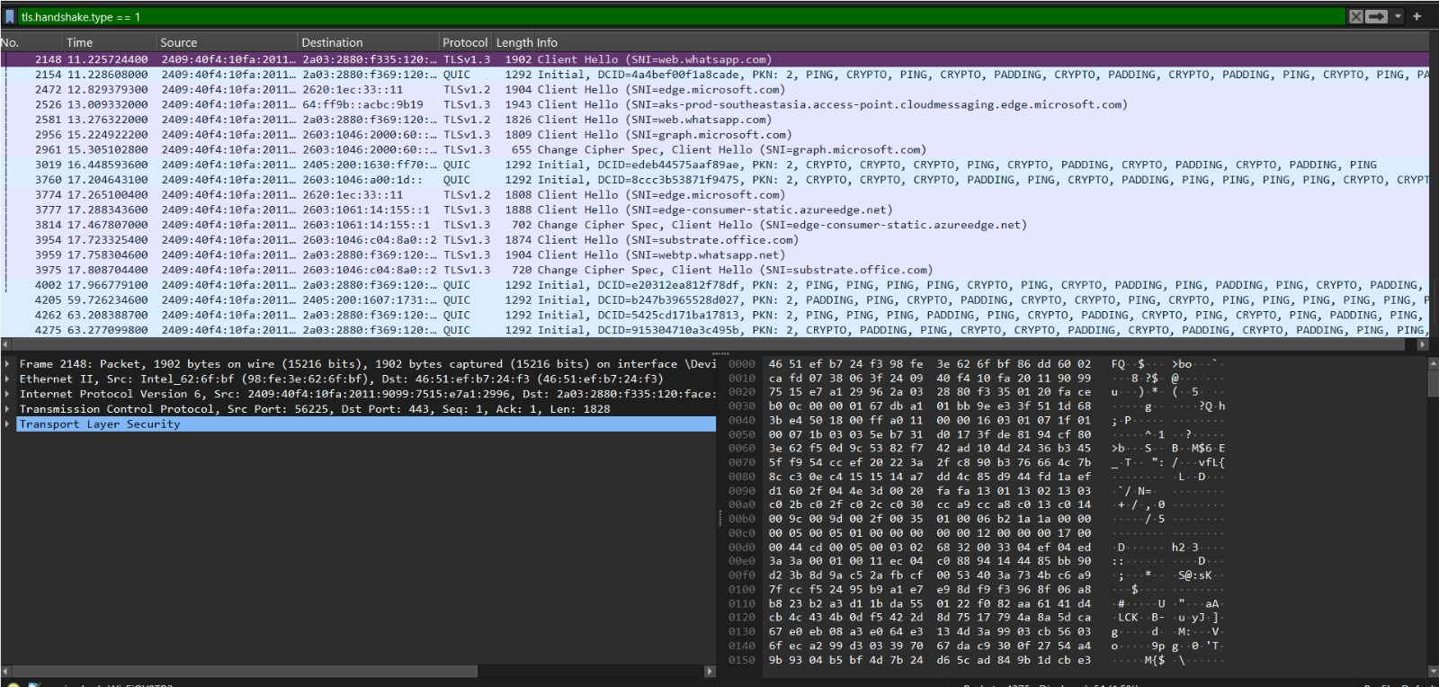
Fig 2: WhatsApp Web traffic showing TCP retransmissions and TLS Application Data on an existing encrypted session.
5. YOUTUBE — QUIC HANDSHAKE
A fresh connection to www.youtube.com was captured from the first DNS lookup through to an active QUIC session with one of YouTube's video CDN servers (a googlevideo.com endpoint, resolved via DNS query for rr1---sn-q4flrnsd.googlevideo.com).
Observed Sequence
- DNS Query/Answer for www.youtube.com, followed by a second DNS lookup for the CDN hostname rr1---sn-q4flrnsd.googlevideo.com — YouTube separates the main site from its video-serving CDN
- Immediately after CDN resolution, a 1292-byte UDP packet was sent directly to port 443 — no TCP SYN at any point, confirming QUIC-over-UDP rather than TCP+TLS
- This first packet was decoded as a QUIC Initial packet (long header form byte 0xc0, QUIC version 0x00000001) carrying an 8-byte Destination Connection ID
- 26 total UDP packets were exchanged with this single CDN endpoint within the capture window, most at or near the 1292-byte QUIC maximum datagram size — consistent with continuous encrypted video segment delivery
Extracted QUIC Initial Packet Details
Field | Value
Header Form | 0xC0 — Long Header, Initial packet type
QUIC Version | 0x00000001 (QUIC v1, RFC 9000)
Destination Connection ID | ce0eabe38063c2f9 (8 bytes)
Transport | UDP, source port 60485 → destination port 443
Payload | Encrypted CRYPTO frame (carries the TLS 1.3 handshake inside QUIC)

Once this handshake completed, all further packets in the session appeared as fully encrypted QUIC short-header packets ('Protected Payload') — continuous encrypted video data with no further visible handshake structure.
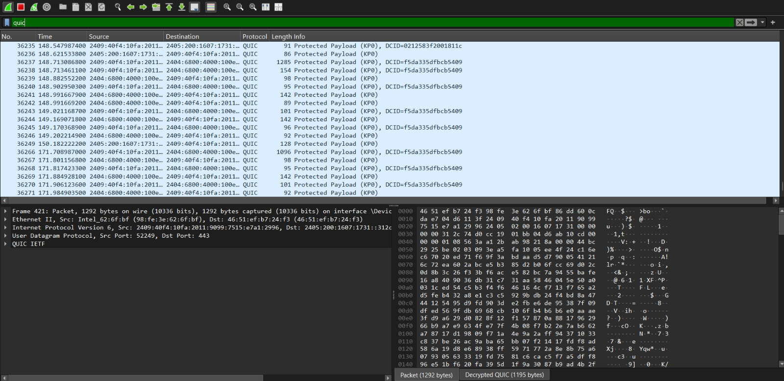
Fig 3: QUIC ‘Protected Payload (KP0)’ packets captured during YouTube video streaming — each ~1292 bytes, the QUIC maximum datagram size.
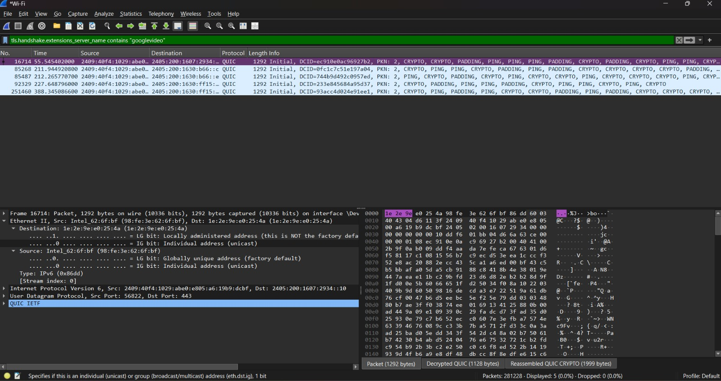
Fig 4: tls.handshake.extensions_server_name_contains “googlevideo” captured during YouTube video streaming
6. TCP+TLS vs QUIC — COMPARISON
Aspect | TCP + TLS 1.3 (GitHub) | QUIC (YouTube)
Transport Layer | TCP | UDP
Handshake Steps | TCP SYN/SYN-ACK/ACK, then separate TLS Client Hello/Server Hello | Single QUIC Initial packet combines transport + TLS 1.3 handshake
Round Trips to Secure Data | 2 round trips (1 TCP + 1 TLS) | 1 round trip (0-RTT possible on resumption)
Head-of-Line Blocking | Present — one lost TCP segment blocks all streams | Avoided — each QUIC stream is independent
Best Suited For | General web browsing, APIs, code hosting | Video streaming, real-time or lossy-network use cases

7. CONCLUSION
This capture-based analysis confirmed the practical differences between legacy TCP+TLS and modern QUIC in real traffic. GitHub's connection followed the classical multi-step TCP+TLS 1.3 handshake with visible Client Hello/Server Hello negotiation, including an early post-quantum key-exchange offer. WhatsApp Web demonstrated TLS session resumption in action. YouTube's use of QUIC showed how Google collapses the handshake into a single UDP round trip, reducing latency — a major reason QUIC is preferred for video streaming, where every millisecond of start-up delay affects user experience.
This exercise strengthened practical understanding of network security fundamentals — directly relevant to embedded systems and IoT work, where secure, low-latency communication design is increasingly important.
8. TOOLS & SKILLS DEMONSTRATED
- Wireshark packet capture and display filtering
- Python/Scapy for offline .pcapng analysis and TLS layer parsing
- TLS 1.2/1.3 handshake structure (Client Hello, Server Hello, Cipher Suites, Key Exchange)
- QUIC protocol fundamentals and Connection ID handling
- DNS resolution and NAT64 address translation in dual-stack networks

